

**LIBRARY MANAGEMENT SYSTEM**

**Group Project**

**Project Report**

UNIFIED MODELING LANGUAGE

DIAGRAM

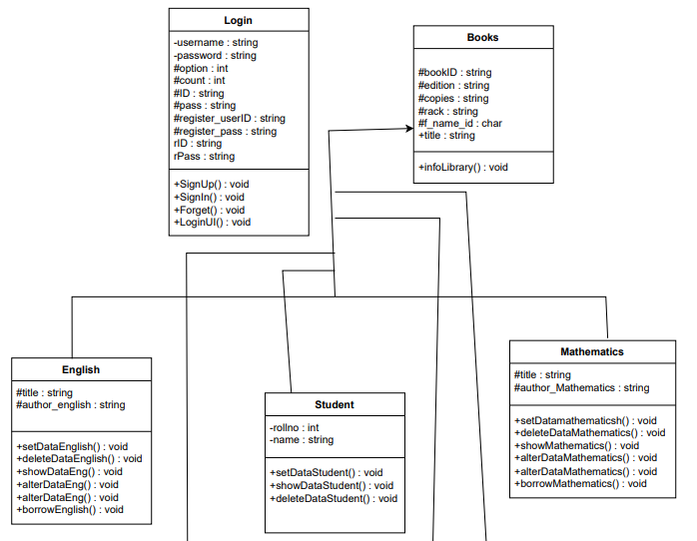

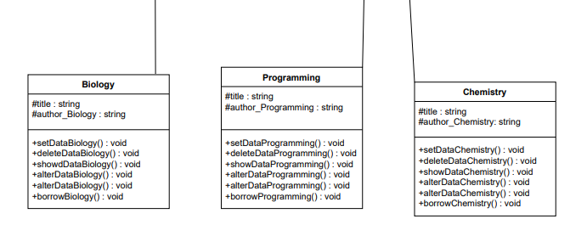



**Air University Multan Campus**

**Project Report**

**Object Oriented Programming**

**Topic:**

**Library Management System**

**Team Members:**

* **Abdul Moaiz (233507)**
* **Ali Raza (233549)**
* **Shumail (233763)**

**Description:**

Library Management System is a Diverse console base project whose main focus is to add simplicity to the daily life of a librarian or a student. This project is an Object-Oriented based Console Application developed through C++. The project also contains a Login system that allows the user to sign up using email and password as well as to login using the same email and password, this also contains a Forget function that basically allows the user to search for their email and password. The project contains detailed number of classes and multiple functions and a file system to store the information. The basic UI of this console base application is presented through functions and the actual data that the user enter to store is called up by the objects of classes. This is a Diverse project that focuses mainly to reduce the amount of effort a person has to make while borrowing a book as well as the librarian who has to store the vast amount of data of the student who borrowed the book. The primary purpose of this Library Management System is to automate various tasks related to library operations. The tasks include book cataloging, lending management, and maintaining an accurate inventory of books. The user can enter books of various subjects like English, Math, Programming, Chemistry, Biology etc. This system also allows the user to delete the books related to these categories as well as to alter and display the record of available books in inventory.

**Project Components:**

* Classes
  + Login Class
  + Student Class
  + Books (Parent Class)
  + English
  + Programming
  + Chemistry
  + Mathematics
  + Biology
* Functions
  + Main Page
  + Interface for Add Book
  + Interface for Delete Book
  + Interface for Show Book Record
  + Interface for Alter Book Record
  + Basic Interface that shows Modules
* Switch cases (Nested in Main Page Function)
* File Handling (To Store Data in Files)
* Conditional Statements (Used to read and write data and check status of file)

**Project Distribution:**

The Project is distributed among the group members in a such way that each of us has performed their tasks and made the modules which were at the last finalized into the project. The work of each team member is mentioned below.

* **Abdul Moaiz (233507) (Lead)**
  + Login Class and all its methods
  + Add Books Method in all classes
  + Alter Book Methods in all classes
  + Assembling the whole project after the modules were made
  + All Functions and UI
  + Delete Book Functionality added in all classes
  + Show or Search Book details Functionality Added in all Classes
* **Shumail (233763)**
  + Borrow Book Functionality added in all classes
  + Add a Student Functionality (Student Class Included)
  + Delete a Student Record
  + Show All Student Record
  + Unified modeling Language Diagram (UML Diagram)
* **Ali Raza (233549)**
  + Information About the Library
  + Return the Book Functionality added in all classes
  + A method to display the record of racks and the books present in those racks to keep record of the books and the library.

**Project Modules:**

* Add a book
  + Add an English Book
  + Add a Programming Book
  + Add a Chemistry Book
  + Add a Biology Book
  + Add a Mathematics Book
* Delete a book
  + Delete an English Book
  + Delete a Programming Book
  + Delete a Chemistry Book
  + Delete a Biology Book
  + Delete a Mathematics Book
* Show Book Details
  + Show Book details for English Category
  + Show Book details for Programming Category
  + Show Book details for Chemistry Category
  + Show Book details for Biology Category
  + Show Book details for Mathematics Category
* Alter Book Details
  + Alter Book Details for English Books
  + Alter Book Details for Programming Books
  + Alter Book Details for Chemistry Books
  + Alter Book Details for Biology Books
  + Alter Book Details for Mathematics Books
* Add a Student Information.
  + Add a New Student
  + Delete a Current Student Record
  + Show Student Report
* Show Information about the library
* Logout
* Exit the program